This Is a directory selector which when you go into you can select the directory you want to go into it.
File Selector
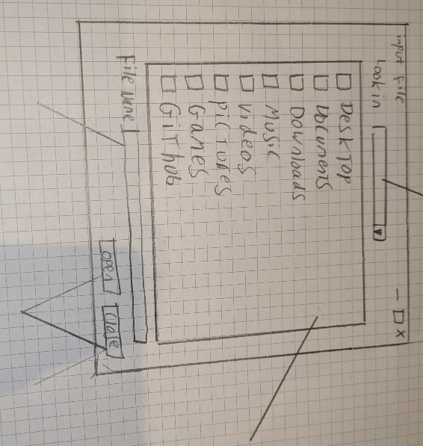
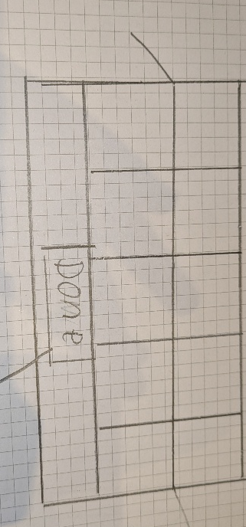
When you click open for the save file you will get the text from this menu and create a new file called the name inputted and save the board to it.
For select file after you press open it will get the name selected and open it and then read the file selected and parse the info into an array to put into the board.
The close button will close the window safely and will skip over reading and writing into a file

Type the file you want to save the board as or to the file you want to select to open.

This is a graphic way to select the file you want to use. Select the file or the folder by double clicking to go into it
Here will be each piece show for each colour so when the user clicks a piece from here it will then go onto the board where that user next click is.
If the user clicks a new piece on the menu the other think that changes is the users selected piece.
Menu for Pieces
The done button will close the window properly so the board can no longer be added to until the Pieces button is clicked again.
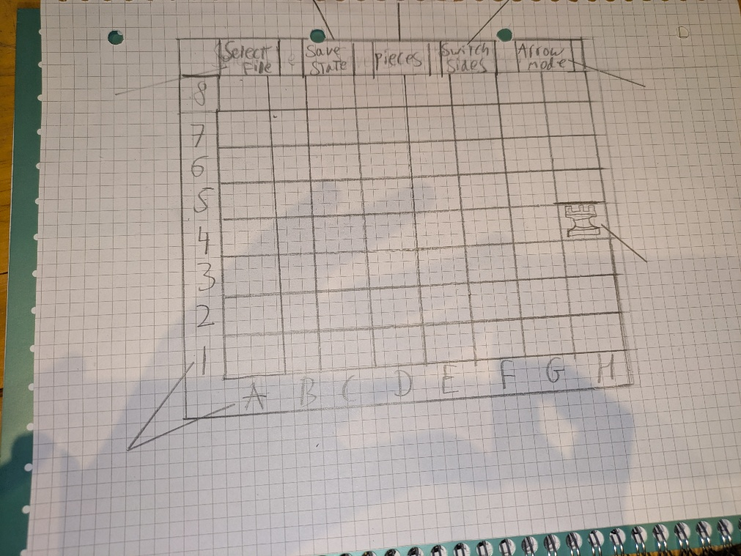
This is the board with a piece on it. The board will be a 2D array of JButtons with a length of 8 and 8 to store the whole grid. The buttons will store a background colour and load images from a file to draw the pieces using icons onto the board. To move a piece simply select the square it is on then select the square you want to move it too. When the piece is moved you need to check if that move is valid and show the square it moved to green or red depending on if the move is valid or not. You can store the pieces onto the JButtons by storing them onto text and then setting the foreground to nothing and the text can not be seen.
The letters and numbers will be stored on in two different JPanel with each letter and number being its own JLabel. Using a grid layout so the board can easily be resized while the letters and numbers stay in alignment to the board. There also will be a way to flip the board simply by changing the text on the JLabel to be reverse so when switched sides is pressed the Side of the board can also switch easily.
When you click the button, the arrow will turn a different colour. Then the user will click a button on the board then a second button. An arrow will be drawn between the two squares with the first button being the start. If the user presses another square the end of the arrow will change to that square. The arrow will disappear and not come back when arrow mode has been re pressed and the colours changed back
When you click this button, the board will flip sides so it will look like what the opposite will see. The grid references on the side of the board.
This will bring up the menu show in bellow with the grids with the pieces in that when you click the button it will make a pop-up window show with each piece shown that the user can click and then click a piece on the board put a piece onto the board.
Save and select file launch a window show in the sketch below where you can select the file and enter a file name as well.

